**Sprint-3**

**Application Building**

**CREATE HTML FILES**

|  |  |
| --- | --- |
| Date | 11 Nov 2022 |
| TeamID | PNT2022TMID09796 |
| ProjectName | Classification of Arrhythmia by Using  Deep Learning with 2-D ECG Spectral  Image Representation |

**TASK:**

***We use HTML to create the front end part of the web page.***

**HTML CODE FOR HOME PAGE:**

<!DOCTYPE html>

<html lang="en">

<head>

<meta charset="UTF-8" />

<meta http-equiv="X-UA-Compatible" content="IE=edge" />

<meta name="viewport" content="width=device-width, initial-scale=1.0" />

<title>Life Care - Heart Prediction Online</title>

<link rel="shortcut icon" href="{{url_for('static',

filename='images/fevicon.png' )}}" type="image/x-icon">

<link rel="stylesheet"

href="https://cdnjs.cloudflare.com/ajax/libs/aos/2.3.1/aos.css" />

<link href="https://fonts.googleapis.com/css2?family=Playfair+Display:wght@600&dis play=swap" rel="stylesheet" />

<link rel="stylesheet" href="{{url_for('static', filename='css/style.css' )}}" />

<script src="https://kit.fontawesome.com/64d58efce2.js" crossorigin="anonymous">

</script>

</head>

<body>

<div class="wrapper">

<!--Navigation Bar-->

<div class="nav">

<div class="logo">

<a href="/">

<img src="static\images\logo.png" style="width:190px" />

</a>

</div>

<div class="links">

<a href="/home" class="mainLink">Home</a>

<a href="/info">Info</a>

<a href="/about">About Us</a>

<a href="/contact">Contact Us</a>

<a href="/upload" class="btn1">Predict</a>

</div>

</div>

<!--Landing Page-->

<div class="landing">

<div class="landingText" data-aos="fade-up" data-aous-duration="1000"> <h1>

Classification of Arrhythmia

<span style="color: #e0501b; font-size: 4vw">Prediction</span>

</h1>

<h3>

According to the World Health Organization (WHO), cardiovascular diseases (CVDs) are the number one cause of death today. Over 17.7 million people died from CVDs in the year 2017 all over the world which...

</h3>

<div class="btn2"><a href="/info">Read more</a>

</div>

</div>

<div class="landingImage" data-aos="fade-down" data-aousduration="2000">

<img src="static/images/banner_img.jpg" alt="bannerImg" style="width: 500px; height:360px" />

</div>

</div>

<!--Service Section-->

<div class="about">

<div class="aboutText" data-aos="fade-up" data-aous-duration="1000">

<h1 style="margin: 20px;">

Our Patients Are at Centre

<span style="color: #2f8be0; font-size: 3vw">of Every We Do</span> </h1>

<div class="image-container">

<img src="/static/images/connsultPationt.png" alt="consultPationt" style="width:400px; margin:100px 0px 0px 90px;"></img>

</div>

</div>

<div class="aboutList" data-aos="fade-left" data-aous-duration="1000">

<ol>

<li>

<span>01</span>

<p>99.8% accurate result.</p>

</li>

<li>

<span>02</span>

<p>No need to go hospital.</p>

</li>

<li>

<span>03</span>

<p>No need to login</p>

</li>

<li>

<span>04</span>

<p>24/7 Support.</p>

</li>

</ol>

</div>

</div>

<!--Info Section-->

<div class="infoSection">

<div class="infoHeader" data-aos="fade-up" data-aous-duration="1000"> <h1>

We Analyse Youe Health states <br /><span style="color: #e0501b">In Order to Top Service.</span>

</h1>

</div>

<div class="infoCards">

<div class="card one" data-aos="fade-up" data-aous-duration="1000">

<img src="static/images/banner_1.svg" class="cardoneImg" alt="" dataaos="fade-up" data-aous-duration="1100" />

<div class="cardbgone"></div>

<div class="cardContent">

<h2>Health State</h2>

<p>

Easy to know Health state

</p>

<a href="/">

<div class="cardBtn">

<img src="static/images/next.png" alt="" class="cardIcon" />

</div>

</a>

</div>

</div>

<div class="card two" data-aos="fade-up" data-aous-duration="1300">

<img src="static/images/banner_1.svg" class="cardtwoImg" alt="" dataaos="fade-up" data-aous-duration="1200" />

<div class="cardbgtwo"></div>

<div class="cardContent">

<h2>User Friendly</h2>

<p>

Easy for people to use, prediction

</p>

<a href="/">

<div class="cardBtn">

<img src="static/images/next.png" alt="" class="cardIcon" />

</div>

</a>

</div>

</div>

<div class="card three" data-aos="fade-up" data-aous-duration="1600">

<img src="static/images/banner_1.svg" class="cardthreeImg" alt="" data-aos="fade-up" data-aous-duration="1000" />

<div class="cardbgthree"></div>

<div class="cardContent">

<h2>Classification of Arrhythmia</h2>

<p>

Prediction Classification of Arrhythmia

</p>

<a href="/upload">

<div class="cardBtn">

<img src="static/images/next.png" alt="" class="cardIcon" />

</div>

</a>

</div>

</div>

</div>

</div>

<!--Banner And Footer-->

<div class="banner">

<div class="bannerText" data-aos="fade-right" data-aousduration="1000">

<h1>

Download the LifeCare App Today <br /><span style="font-size: 1.6vw; font-weight: normal" class="bannerInnerText">Stay Updated and get all your medical needs

taken care of!</span>

</h1>

<a href="/"><img src="static/images/AndroidPNG.png" alt="" /></a>

<a href="/"><img src="static/images/iosPNG.png" alt="" /></a>

</div>

<div class="bannerImg" data-aos="fade-up" data-aous-duration="1000">

<img src="static/images/app.png" alt="" />

</div>

</div>

<div class="footer">

<h1>LifeCare</h1>

<div class="footerlinks">

<a href="/home" class="mainLink">Home</a>

<a href="/info">Info</a>

<a href="/about">About Us</a>

<a href="/contact">Contact Us</a>

</div>

</div>

</div>

<script src="https://cdnjs.cloudflare.com/ajax/libs/aos/2.3.1/aos.js"></script>

<script>

AOS.init();

</script>

**HOME PAGE (SCREEN SHOT):**

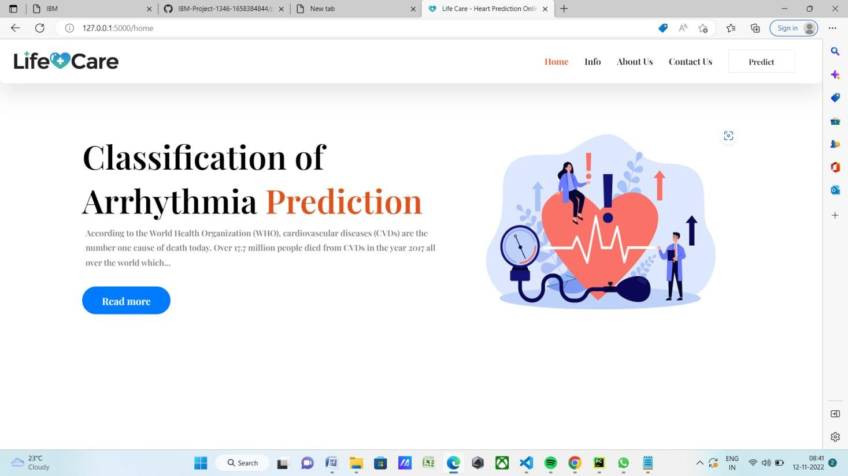

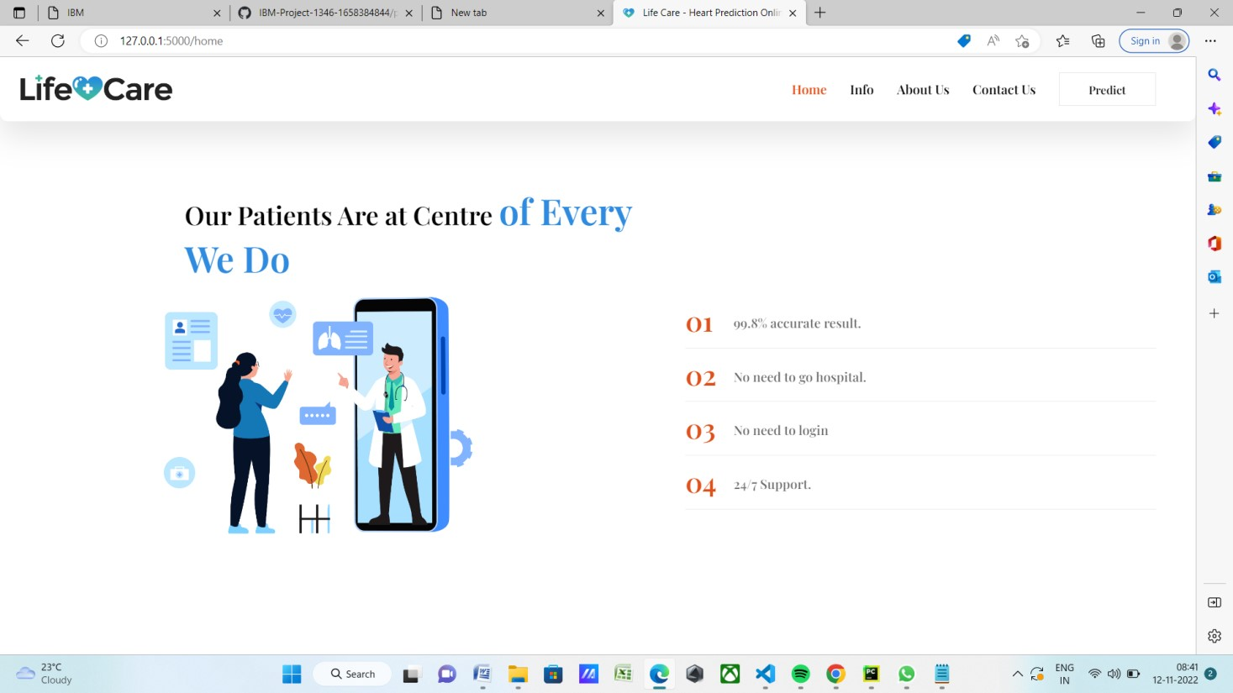

**HTML CODE FOR**  **INFO PAGE:**

<!DOCTYPE html>

<html lang="en">

<head>

<meta charset="UTF-8" />

<meta http-equiv="X-UA-Compatible" content="IE=edge" />

<meta name="viewport" content="width=device-width, initialscale=1.0" />

<title>Life Care - About Classification of Arrhythmia</title>

<link rel="shortcut icon" href="{{url_for('static',

filename='images/fevicon.png' )}}" type="image/x-icon">

<link rel="stylesheet"

href="https://cdnjs.cloudflare.com/ajax/libs/aos/2.3.1/aos.css" />

<link

href="https://fonts.googleapis.com/css2?family=Playfair+Display:wght@

600&display=swap" rel="stylesheet" />

<link rel="stylesheet" href="{{url_for('static', filename='css/style.css' )}}" />

<script src="https://kit.fontawesome.com/64d58efce2.js" crossorigin="anonymous">

</script>

<style> .banner { margin: 60px; width: auto; height: 300px; /* Setup */ background-color: #fff; box-shadow: rgba(0, 0, 0, 0.15) 2.4px 2.4px 3.2px; display: flex; flex-direction: row; padding: 50px;

}

.bannerText h1 { font-size: 3vw; color: #007bff; font-weight: 600;

}

.bannerText p { text-indent: 50px; color: #777777; font-size: 1.2vw; font-weight: normal

}

.bannerText img { width: 10vw; margin-right: 20px;

}

.bannerImg img { margin-left: 90px; width: 350px;

}

</style>

</head>

<body>

<div class="wrapper">

<!--Navigation Bar-->

<div class="nav">

<div class="logo">

<a href="/"><img src="static/images/logo.png" alt="Website

Title" style="width:190px" /></a>

</div>

<div class="links">

<a href="/home">Home</a>

<a href="/info" class="mainLink">info</a>

<a href="/about">About Us</a>

<a href="/contact">Contact Us</a>

<a href="/upload" class="btn1">Predict</a>

</div>

</div>

<!--Landing Page-->

<div class="landing">

|  |  |
| --- | --- |
| <div class="landingText" data-aos="fade-up" duration="1000">  <h1>  Classification of Arrhythmia | data-aous- |
| <span style="color: #e0501b; | font-size: |

4vw">Prediction</span>

</h1> <h3>

According to the World Health Organization (WHO), cardiovascular diseases (CVDs) are the number one

cause of death today. Over 17.7 million people died from CVDs in the year

2017 all over the world which is about

31% of all deaths, and over 75% of these deaths occur in low and middle-income countries. Arrhythmia is a representative

type of CVD that

refers to any irregular change from the normal heart rhythms.

There are several types of arrhythmia

including atrial fibrillation, premature contraction, ventricular fibrillation, and tachycardia. Although a single arrhythmia heartbeat may not have a serious impact on life, continuous arrhythmia beats can result in fatal circumstances.

</h3>

</div>

<div class="landingImage" data-aos="fade-down" data-aousduration="2000">

<img src="static/images/banner_img.jpg" alt="bannerImg" style="width: 500px; height:360px" />

</div>

</div>

<div class="banner">

<div class="bannerText" data-aos="fade-right" data-aousduration="1000">

<h1>

Left Bundle Branch

</h1>

<p>A delay blockage of electrical impulses to the left of the heart. Left bundle brach block sometimes makes it harder for the heart to pump blood efficiently through the circulatory

system.</p>

<p>Most people don't have symptoms. If symtoms occur, they inlcude fainting or a slow heart rate.</p>

<p>If there's an underlying condition, such as heart disease, that condition needs treatment. In patients with heart failure, a pacemaker can also relieve symptoms as well as prevent death.</p>

</div>

|  |  |
| --- | --- |
| <div class="bannerImg" data-aos="fade-up" duration="1000">  <img src="static/images/LBB.svg" alt="" />  </div>  </div>  <div class="banner"> | data-aous- |
| <div class="bannerText" data-aos="fade-right" | data-aous- |

duration="1000">

<h1>

Normal

</h1>

<p>Note that the heart is beating in a regular sinus rhythm between 60-100 beats per minute (specifically 82 bpm).</p>

<p>All the important intervals

on this recording are within

normal ranges.</p> <p>The normal ECG patterns seen in children differ considerably from those in adults.</p>

</div>

|  |  |
| --- | --- |
| <div class="bannerImg" data-aos="fade-up" duration="1000">  <img src="static/images/normal.svg" alt="" />  </div>  </div>  <div class="banner"> | data-aous- |
| <div class="bannerText" data-aos="fade-right" | data-aous- |

duration="1000">

<h1>

Premature Atrial Contraction

</h1>

<p>usually, premature artial contraction have no clear cause and no health risks. In most cases, premature artrial contractions aren't a sign of heart disease and just happen naturally.</p>

<p>But some people who have PACs turn out to have related heart conditions, such as

Cardiomyopathy (a weakend heart muscle)

Caronary heart disease (fatty deposits in you blood vessels)</p>

</div>

<div class="bannerImg" data-aos="fade-up" data-aousduration="1000">

<img src="static/images/PAC.jpg" alt="" />

</div>

</div>

<div class="banner">

<div class="bannerText" data-aos="fade-right" data-aousduration="1000">

<h1>

Premature Ventricular Contractions

</h1>

<p>Extra, abnorma heartbeats that begininone of the

Heart's two lower chambers.</p>

<p>Premature ventricular contractions (PVCs) occur in most people at some point. Causes may include certain medication, alcohol, some illegal drugs, caffeine, tobacco, excercise or anxiety.</p>

<p>

PVCs often cause no symtoms. When symptoms do occur, they feel like a flip-flop or skipped-beat sensation in the chest.

</p>

<p>Most people with isolated PVCs and an otherwise normal heart don't need treatment. PVCs occurring

continuously serious cardiac than 30 seconds is a potentially serious cardiac condition known as ventriclular tachycardia.</p>

</div>

|  |  |
| --- | --- |
| <div class="bannerImg" data-aos="fade-up" duration="1000">  <img src="static/images/PVC.jpg" alt="" />  </div>  </div>  <div class="banner"> | data-aous- |
| <div class="bannerText" data-aos="fade-right" | data-aous- |

duration="1000">

<h1>

Right Bundle Branch

</h1>

<p>Right bundle branch block is associated with structural changes from strech or ischemia to the myocardium. It can also occur iatorgenically from certain common cardiac precedures, such as right heart catheterization.</p> <p>Although there is no significant association with cardiovascular risk factors, the presence with cardiovascular risk factors, the presence of a right bundle branch block is a predictor of mortality in myocardial infarction, heart failure, and certain heart blocks.</p>

<p>In asymptomatic patients, isolated right bundle

brach block typically does not need further evaluation.</p>

</div>

|  |  |
| --- | --- |
| <div class="bannerImg" data-aos="fade-up" duration="1000">  <img src="static/images/RBB.svg" alt="" />  </div>  </div>  <div class="banner"> | data-aous- |
| <div class="bannerText" data-aos="fade-right" | data-aous- |

duration="1000">

<h1>

Ventricular Fibrillation

</h1>

<p>A life-threatening heart rhythm that results in a rapid, inadeuate heartbeat.</p>

<p>Ventricular fibrillation (VF) is a rapid,

Life-threatening heart rhythm starting in the bottom chambers of the heart. It can be triggered by a heart attack.</p>

<p>Because the heart doesn't pump adequately during ventricular fibrillation, sustained VF can cause low blood pressure, losso f consciousness of death.</p>

<p>Emergency treatment includes immediate defibrillation with a n automated external defibrillator (AED) and cardiopulmonary resuscitation(CPR). Long-term therapy includes

implantable defibrillators and medcations to prevent recurrence.</p>

</div>

<div class="bannerImg" data-aos="fade-up" data-aousduration="1000">

<img src="static/images/VF.png" alt="" />

</div>

</div>

<div class="footer">

<h1>LifeCare</h1>

<div class="footerlinks">

<a href="/home">Home</a>

<a href="/info" class="mainLink">Info</a>

<a href="/about">About Us</a>

<a href="/conduct">Contact Us</a>

</div>

</div>

</div>

<script src="https://cdnjs.cloudflare.com/ajax/libs/aos/2.3.1/aos.js"></script>

<script>

AOS.init();

</script>

**INFO PAGE (SCREEN SHOT):**

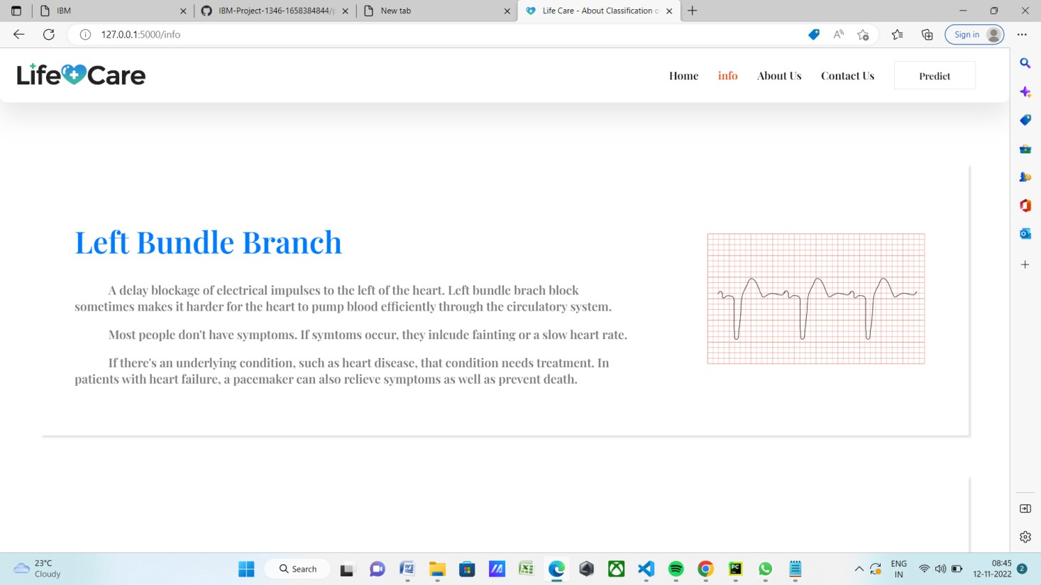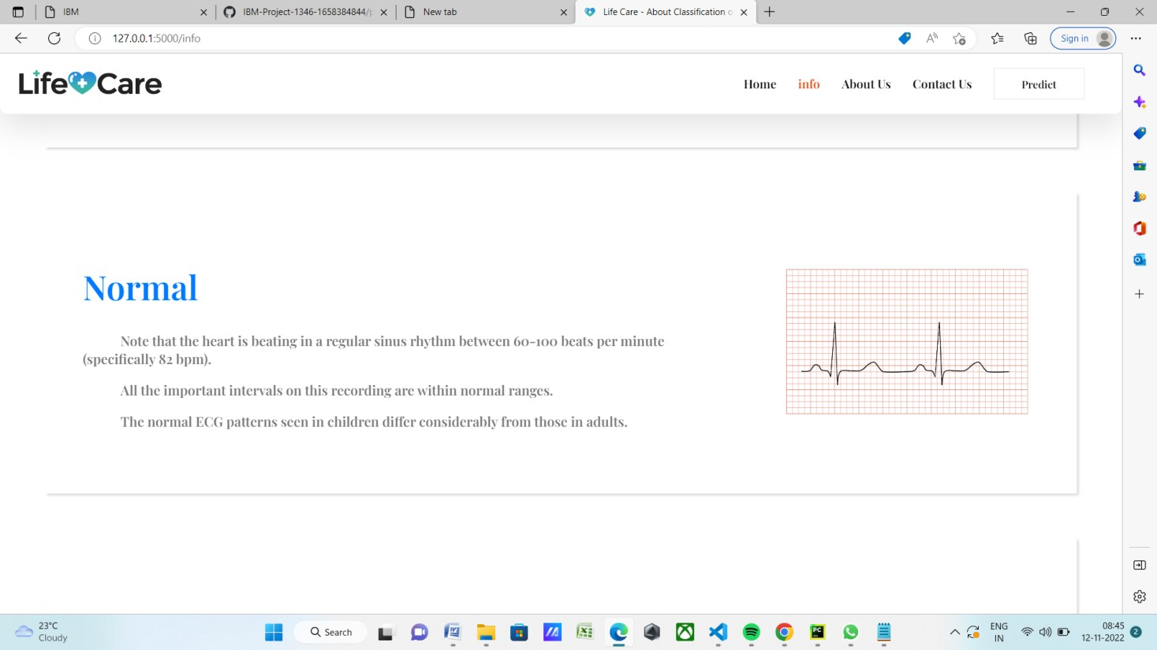

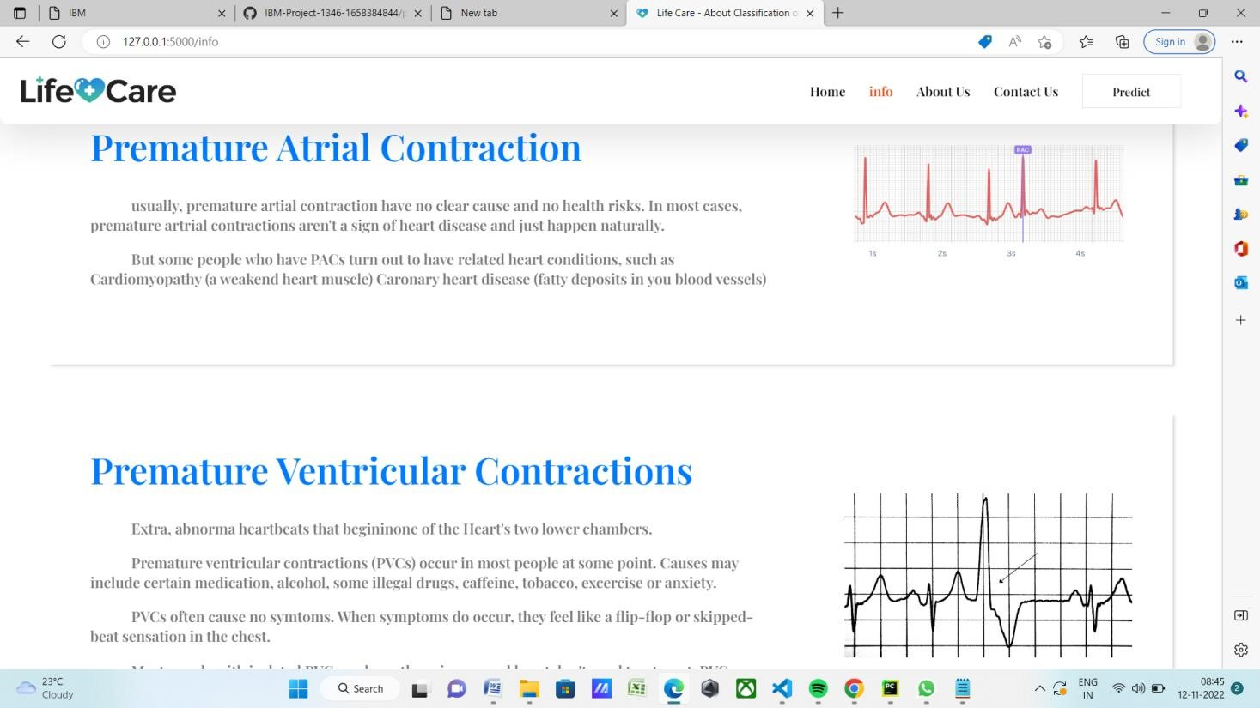

**HTML CODE FOR ABOUT PAGE:**

<!DOCTYPE html>

<html lang="en">

<head>

<meta charset="UTF-8">

<meta http-equiv="X-UA-Compatible" content="IE=edge">

<meta name="viewport" content="width=device-width, initial-scale=1.0">

<link rel="shortcut icon" href="{{url_for('static', filename='images/fevicon.png'

)}}" type="image/x-icon">

<title>Life Care - About Us</title>

<link rel="stylesheet" href="{{url_for('static', filename='css/about.css')}}">

<link rel="stylesheet" href="{{url_for('static', filename='css/style.css')}}">

<link rel="stylesheet"

href="https://cdnjs.cloudflare.com/ajax/libs/aos/2.3.1/aos.css" />

<link

href="https://fonts.googleapis.com/css2?family=Playfair+Display:wght@600&dis play=swap" rel="stylesheet" />

<link href="https://cdnjs.cloudflare.com/ajax/libs/font-

awesome/5.10.0/css/all.min.css" rel="stylesheet">

</head>

<style>

.footer { margin-bottom: 20px;

}

h1 { margin: 21.44px 0px;

}

</style>

<body>

<div class="wrapper">

<!--Navigation Bar-->

<div class="nav">

<div class="logo">

<a href="/"><img src="static/images/logo.png" alt="Website Title" style="width:190px" /></a>

</div>

<div class="links">

<a href="/">Home</a>

<a href="/info">Info</a>

<a href="/about" class="mainLink">About Us</a>

<a href="/contact">Contact Us</a>

<a href="/upload" class="btn1">Predict</a>

</div>

</div>

<div class="landing">

<div class="landingText" data-aos="fade-up" data-aous-duration="1000">

<h1>

We are a team of

<span style="color: #e0501b; font-size: 4vw">Arrthymia

Prediction</span>

</h1>

<h3>

In this project, we build an effective electrocardiogram (ECG) arrhythmia classification method

using a convolutional

neural network (CNN), in which we classify ECG into seven categories, one being normal and the other

six being different

types of arrhythmia using deep two-dimensional CNN with grayscale ECG images. We are creating a web

application where the user selects the image which is to be classified. The image is fed into the model that is trained and the cited class will be displayed on the webpage.

</h3>

</div>

<div class="landingImage" data-aos="fade-down" data-aousduration="2000">

<img src="static/images/about_us.png" alt="aboutImg" style="width:

450px; height:450px" />

</div>

</div>

<div class="main">

<div class="profile-card">

<div class="img">

<img src="static/images/profile_avatar.png">

</div>

<div class="caption">

<h3>Muthamizhan Rio</h3>

<p>Professional Deep Learning Engineer, Back End Developer</p>

<div class="social-links">

<a href="#"><i class="fab fa-facebook"></i></a>

<a href="#"><i class="fab fa-instagram"></i></a>

<a href="#"><i class="fab fa-twitter"></i></a>

</div>

</div>

</div>

<div class="profile-card">

<div class="img">

<img src="static/images/profile_avatar.png">

</div>

<div class="caption">

<h3>Vignesh </h3>

<p>Full Stack Developer, Web Designer, Deep Learning

Engineer</p>

<div class="social-links">

<a href="#"><i class="fab fa-facebook"></i></a>

<a href="https://www.instagram.com/the_._._champ/"><i class="fab fa-instagram"></i></a>

<a href="#"><i class="fab fa-twitter"></i></a>

</div>

</div>

</div>

<div class="profile-card">

<div class="img">

<img src="static/images/profile_avatar.png">

</div>

<div class="caption">

<h3>Vetriselvan</h3>

<p>Back End Developer</p>

<div class="social-links">

<a href="#"><i class="fab fa-facebook"></i></a>

<a href="#"><i class="fab fa-instagram"></i></a>

<a href="#"><i class="fab fa-twitter"></i></a>

</div>

</div>

</div>

<div class="profile-card">

<div class="img">

<img src="static/images/profile_avatar.png">

</div>

<div class="caption">

<h3>Bharathidasan</h3>

<p>Front End Developer</p>

<div class="social-links">

<a href="#"><i class="fab fa-facebook"></i></a>

<a href="#"><i class="fab fa-instagram"></i></a>

<a href="#"><i class="fab fa-twitter"></i></a>

</div>

</div>

</div>

</div>

<div class="footer">

<h1>LifeCare</h1>

<div class="footerlinks">

<a href="/home">Home</a>

<a href="/info">Info</a>

<a href="/about">About Us</a>

<a href="/contact">Contact Us</a>

</div>

</div>

</div>

</div>

<script src="https://cdnjs.cloudflare.com/ajax/libs/aos/2.3.1/aos.js"></script> <script>

AOS.init();

</script>

**ABOUT PAGE(SCREEN SHOT):**

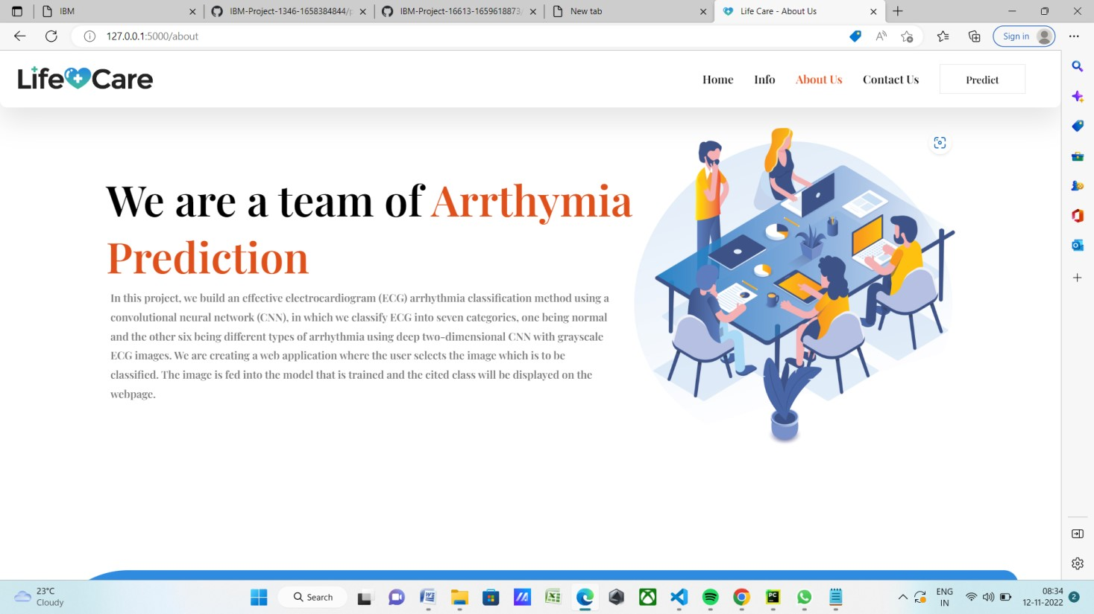

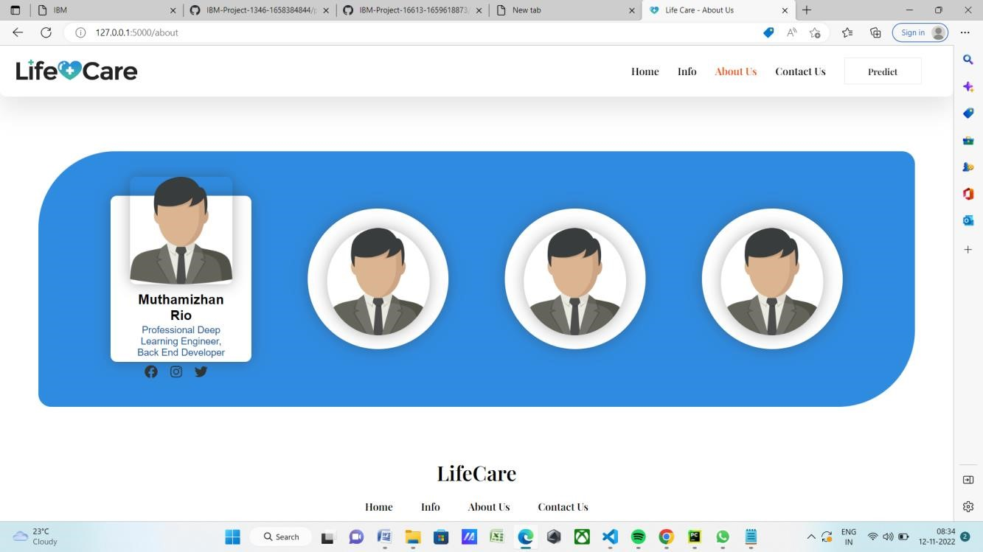

**HTML CODE FOR CONTACT PAGE:**

<!DOCTYPE html>

<html lang="en">

<head>

<meta charset="UTF-8">

<meta http-equiv="X-UA-Compatible" content="IE=edge">

<meta name="viewport" content="width=device-width, initialscale=1.0">

<link rel="shortcut icon" href="{{url_for('static',

filename='images/fevicon.png' )}}" type="image/x-icon">

<link rel="stylesheet"

href="https://cdnjs.cloudflare.com/ajax/libs/aos/2.3.1/aos.css" />

<link rel="stylesheet" href="https://cdnjs.cloudflare.com/ajax/libs/fontawesome/5.15.3/css/all.min.css" />

<link

href="https://fonts.googleapis.com/css2?family=Playfair+Display:wght@

600&display=swap" rel="stylesheet" />

<link rel="stylesheet" href="{{url_for('static', filename='css/contact.css' )}}" />

<link rel="stylesheet" href="{{url_for('static', filename='css/style.css'

)}}" />

<title>Life Care - Contact US</title>

</head>

<body>

<div class="wrapper">

<div class="nav">

<div class="logo">

<a href="/">

<img src="static\images\logo.png" style="width:190px" />

</a>

</div>

<div class="links">

<a href="/home" class="mainLink">Home</a>

<a href="/info">Info</a>

<a href="/about">About Us</a>

<a href="/contact">Contact Us</a>

<a href="/upload" class="btn1">Predict</a>

</div>

</div>

|  |  |  |
| --- | --- | --- |
| <div class="container" duration="1000"> | data-aos="fade-down" | data-aous- |
| <div class="image" | data-aos="fade-right" | data-aous- |

duration="6000">

<img src="static/images/contact.png" alt="">

</div>

<div class="form-area">

<h2>Contact US</h2>

<form action="">

<input type="text" placeholder="Full Name">

<input type="email" placeholder="Email">

<input type="text" placeholder="Subject">

<textarea cols="30" rows="3" placeholder="Your

Message"></textarea>

<button type="submit">Send Message</button>

</form>

</div>

</div>

</div>

<script src="https://cdnjs.cloudflare.com/ajax/libs/aos/2.3.1/aos.js"></script>

<script>

AOS.init();

</script>

**CONTACT PAGE (SCREEN SHOT):**

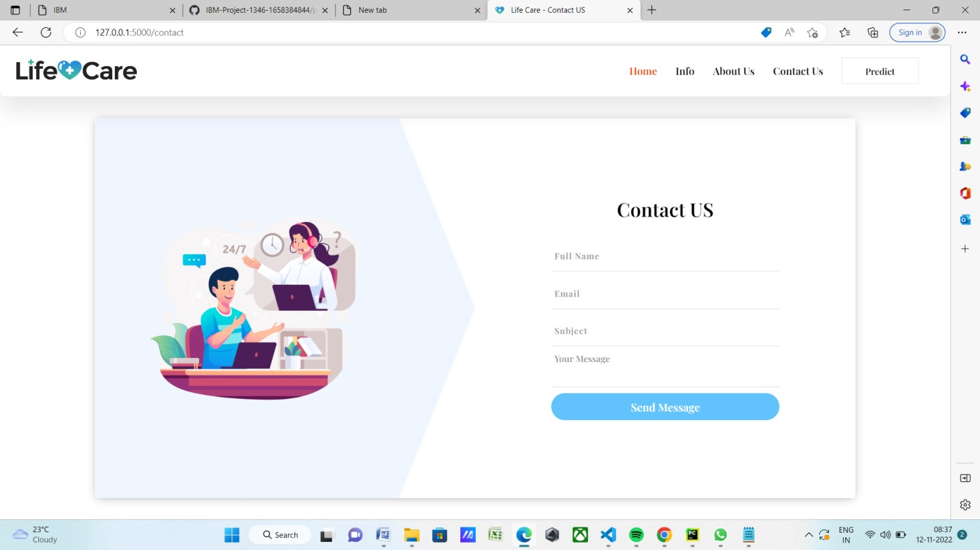

**HTML CODE FOR PREDICT PAGE:**

{% extends "predict_base.html" %} {% block content %}

<center>

<h2 style="font-size: 40px;">

ECG Arrhythmia

<span style="color: #2f8be0; font-size: 3vw">Classification</span>

</h2>

</center>

<div>

<form id="upload-file" method="post" enctype="multipart/form-data">

<center> <label for="imageUpload" class="upload-label">

Choose...

</label>

<input type="file" name="file" id="imageUpload" accept=".png, .jpg,

.jpeg">

</center>

</form>

<center>

<div class="image-section" style="display:none;">

<div class="img-preview">

<div id="imagePreview">

</div>

</div>

</div>

</center>

</div>

<center>

<div class="btn3" id="btn-predict" style="padding: 8px 34px; width: 120px; margin-top: 30px; padding: 14px 20px 12px 20px; background-color: #007bff; border-radius: 45px; text-align:

center; color: #fff; cursor: pointer;">

Predict</div>

<div class="loader" style="display:none;"></div>

</center>

<h3 style="color:Black" id="result">

<span> </span>

</h3>

</div>

</div>

**PREDICT PAGE (SCREEN SHOT):**

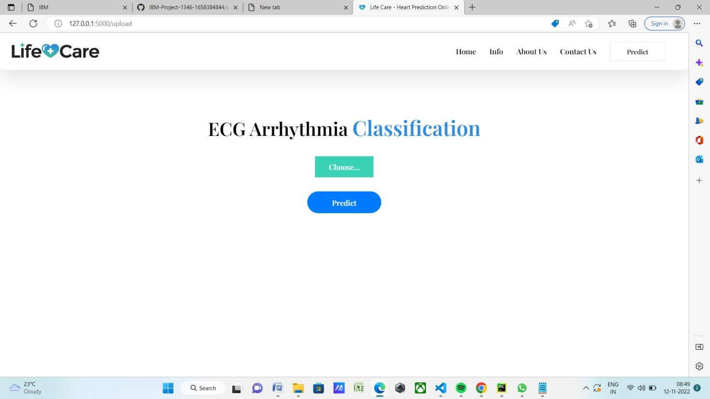

**HTML CODE FOR PREDICT_BASE PAGE:**

<!DOCTYPE html>

<html lang="en">

<head>

<meta charset="UTF-8" />

<meta http-equiv="X-UA-Compatible" content="IE=edge" />

<meta name="viewport" content="width=device-width, initialscale=1.0" />

<title>Life Care - Heart Prediction Online</title>

<link rel="shortcut icon" href="{{url_for('static',

filename='images/fevicon.png' )}}" type="image/x-icon">

<link rel="stylesheet"

href="https://cdnjs.cloudflare.com/ajax/libs/aos/2.3.1/aos.css" />

<link

href="https://fonts.googleapis.com/css2?family=Playfair+Display:wght@

600&display=swap" rel="stylesheet" />

<script src="https://cdn.bootcss.com/popper.js/1.12.9/umd/popper.min.js"></scri pt>

<script src="https://cdn.bootcss.com/jquery/3.3.1/jquery.min.js"></script>

<script src="https://cdn.bootcss.com/bootstrap/4.0.0/js/bootstrap.min.js"></script >

<link href="{{ url_for('static', filename='css/main.css') }}" rel="stylesheet">

<link rel="stylesheet" href="{{url_for('static', filename='css/style.css' )}}" />

<script src="https://kit.fontawesome.com/64d58efce2.js" crossorigin="anonymous">

</script>

</head>

<body>

<div class="wrapper">

<!--Navigation Bar-->

<div class="nav">

<div class="logo">

<a href="/">

<img src="static\images\logo.png" style="width:190px" />

</a>

</div>

<div class="links">

<a href="/">Home</a>

<a href="/info">Info</a>

<a href="/about">About Us</a>

<a href="/contact">Contact Us</a>

<a href="/upload" class="btn1">Predict</a>

</div>

</div>

<!--Landing Page-->

<div class="landing">

<div class="landingText" data-aos="fade-up" data-aousduration="10000">

<h1>

Classification of Arrhythmia

<span style="color: #e0501b; font-size:

4vw">Prediction</span>

</h1> <h3>

According to the World Health Organization (WHO), cardiovascular diseases (CVDs) are the number one cause of

death today. Over 17.7 million people died from CVDs in the year 2017 all over the world which...

</h3>

<div class="btn2"><a href="/info">Read more</a>

</div>

</div>

<div class="landingImage" data-aos="fade-down" data-aousduration="2000">

<img src="static/images/banner_img.jpg" alt="bannerImg" style="width: 500px; height:360px" />

</div>

</div>

<div class="about">

<div class="aboutText" data-aos="fade-up" data-aousduration="1000">

{% block content %}{% endblock %}

</div>

</div>

<div class="footer">

<h1>LifeCare</h1>

<div class="footerlinks">

<a href="/home">Home</a>

<a href="/info">Info</a>

<a href="/about">About Us</a>

<a href="/contact">Contact Us</a>

</div>

</div>

</div>

<script src="https://cdnjs.cloudflare.com/ajax/libs/aos/2.3.1/aos.js"></script>

<script>

AOS.init();

</script>

</body>

<footer>

<script src="{{ url_for('static', filename='js/main.js') }}" type="text/javascript"></script>

**PREDICT_BASE PAGE (SCREEN SHOT):**

